Post 1
Did you know? Rain barrels help protect our local waterbodies by collecting water that would otherwise run off into the storm sewers, carrying with it pollutants such as oil, bacteria, nutrients to lakes and streams. Harvested water can be used on lawns, gardens, and landscaped areas.
Join us in protecting our local waterbodies by ordering a rain barrel today! www.ripple-effects.com/rainbarrels #MAMSWaP #Ripple-Effects
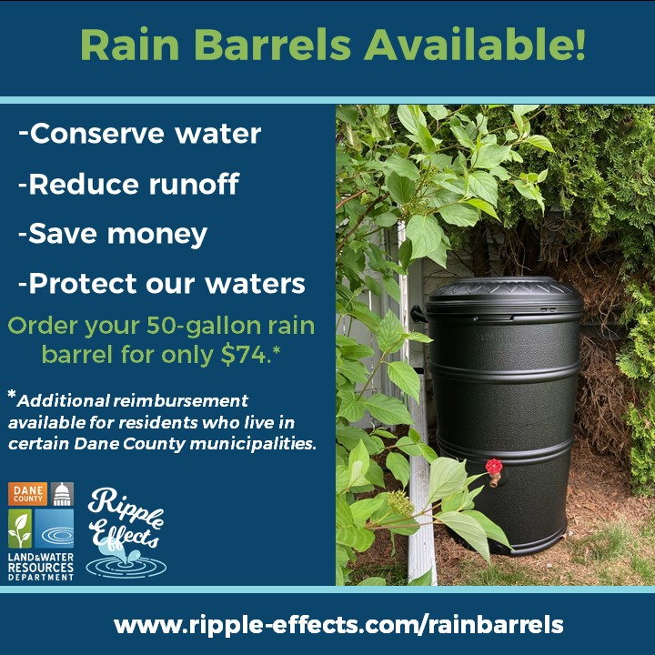

Post 2
Did you know?
Rain barrels are a great way to conserve water during the hot summer months. Order a rain barrel today! www.ripple-effects.com/rainbarrels
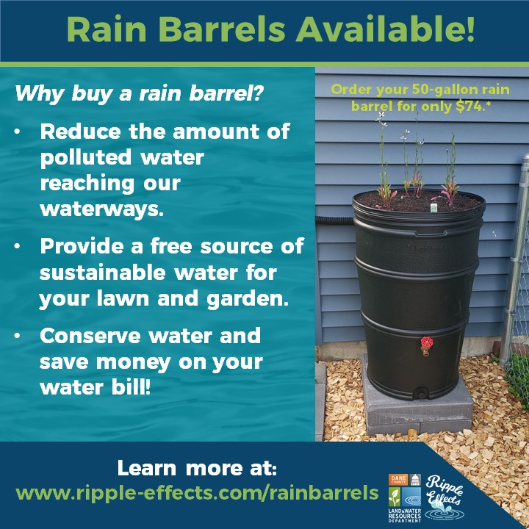

Post 3
Are you a Dane County resident or business interested in protecting our local waters? Order a 50-gallon rain barrel for only $74 (typically retails for ~$150). If you live in a Madison Area Municipal Stormwater Partnership community, you are eligible to apply for an additional $30 reimbursement!
For more information on how to order a rain barrel or available reimbursement programs, visit: www.ripple-effects.com/rainbarrels.
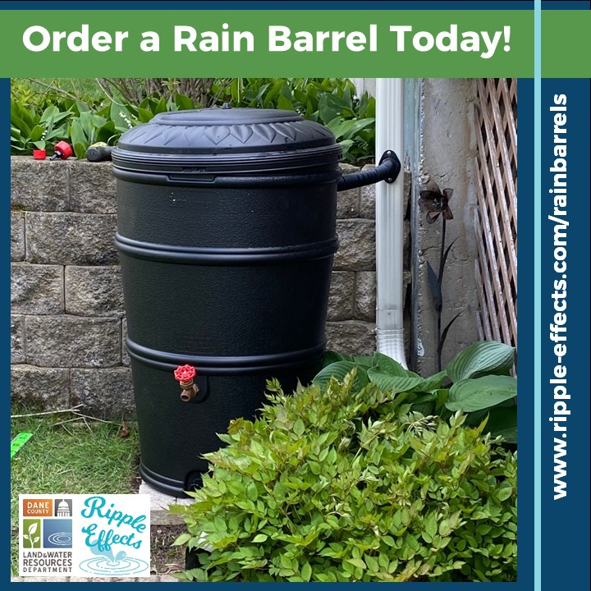

Post 4
We can reduce stormwater runoff by collecting rainwater to be used later. Less runoff means less strain on our storm sewer systems and less pollution entering our lakes, rivers and streams. Order a rain barrel today: www.ripple-effects.com/rainbarrels
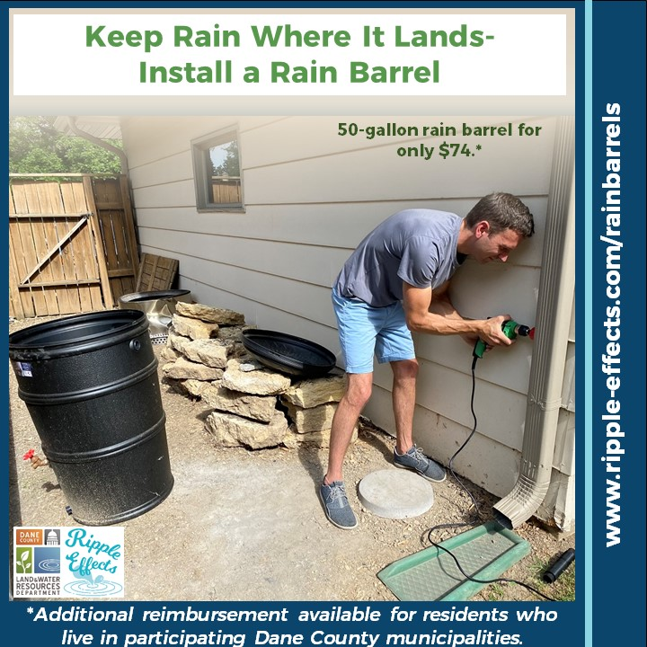

Post 5
Small actions can make a BIG difference! Order a rain barrel today! www.ripple-effects.com/rainbarrels
