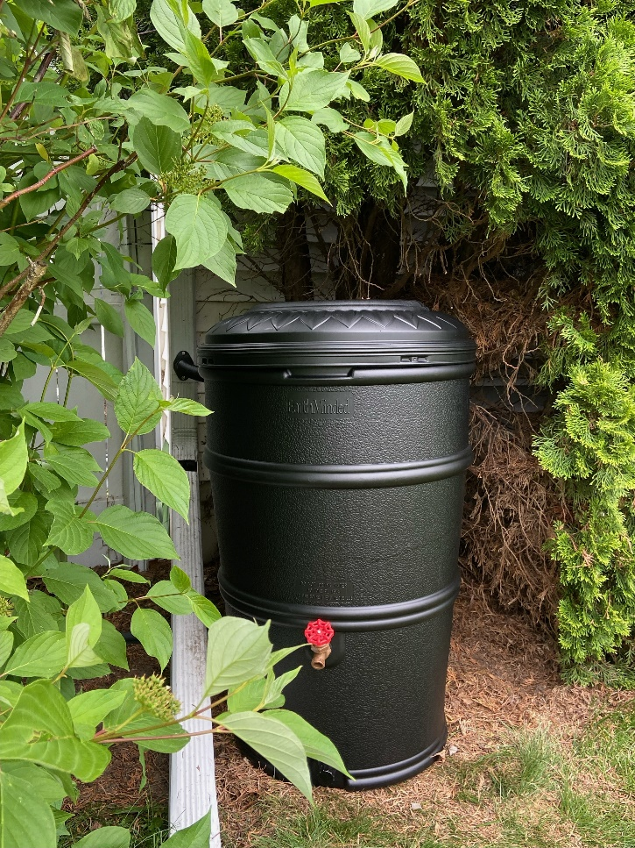
Soak up the Rain: Low-Cost Rain Barrels for Sale
Did you know that about 600 gallons of rain run off a 1,000 sq. ft. roof during a 1-inch storm? All that runoff washes down our storm drains carrying trash, dirt, oil and other pollution to our local waters. Rain barrels are a great way to capture some of that runoff and protect our lakes and streams. Harvested water can be used during dry spells to water lawns, gardens, and potted plants, which helps conserve water and reduce your water bill!
Dane County and the Madison Area Municipal Stormwater Partnership are selling 50-gallon rain barrels at a discounted rate of $74 (typically retails for ~$150). This program is open to all Dane County residents and businesses. If you live in a MAMSWaP community, you are eligible to apply for an additional $30 reimbursement. Rain barrels will be available for pickup at the Middleton Recycling Center and Deforest Yardwaste Collection Site during normal operating hours for those facilities.
For more information on how to order a rain barrel, and how to apply for available reimbursement programs, please visit: www.ripple-effects.com/rainbarrels. Your actions have a Ripple Effect on our waters!

