**Salt Awareness Social Media**

Use salt hashtags as you see fit: #saltwiseshoutout; #sweepthesalt; #thetruecostofsalt; #keepfreshwaterfresh

**Posting Schedule- Post at 6AM each day**

Post 1- Birds: Dec 15th

Post 2- Sweep it Up: Dec 22nd

Post 3-Pets: Dec 29th

Post 4-Headphones: Jan 5th

Post 5- Once You Put It Down…: Jan 11th

Post 6-Socially Distanced: Jan 19th

Post 7- Shark-free Waters: Jan 26th

Post 8- Teaspoon of Salt: Feb 2nd

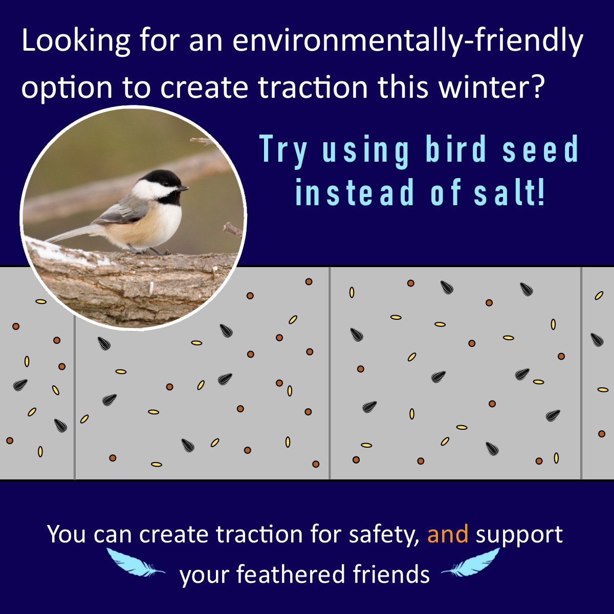

**Post 1:** Over-salting is for the birds. When temps are below 15 degrees, salt doesn’t work to melt snow and ice. Support feathery friends AND protect freshwater by using birdseed for traction instead. Join the salt reduction revolution during WI Salt Awareness Week, Jan. 11-15. Register online: www.wisaltwise.com @WISaltWise

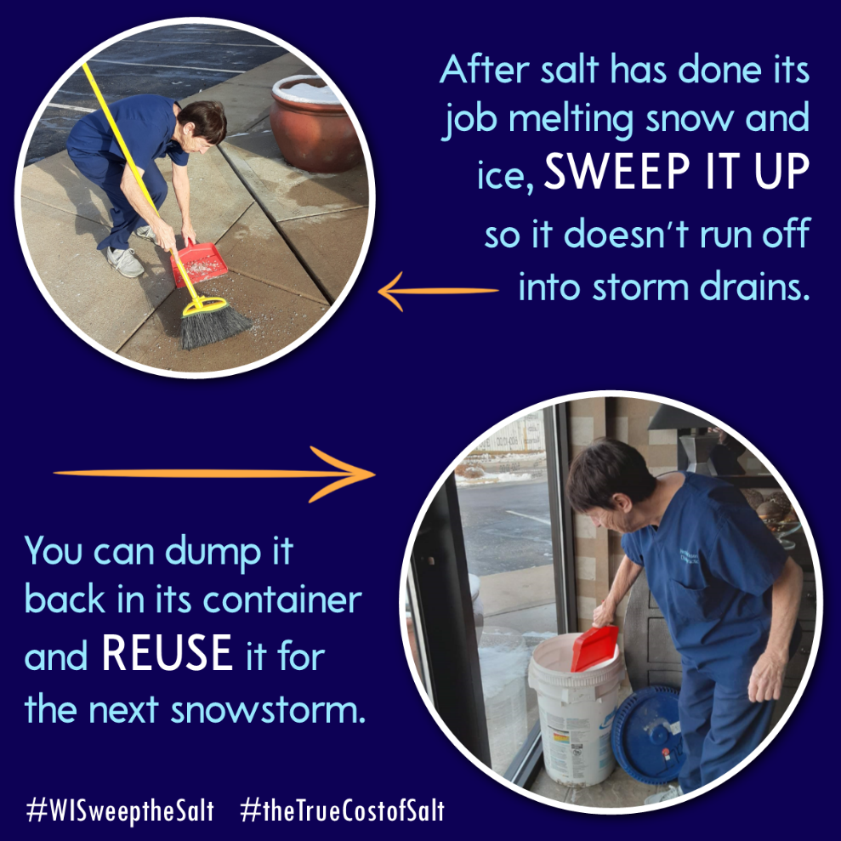

**Post 2:** Salt might appear to disappear, but it doesn’t “go away.” Be a freshwater champion, and #sweepthesalt. Learn more the impacts of over-salting during WI Salt Awareness Week, January 11-15. Register online: www.wisaltwise.com @WISaltWise



**Post 3:** Shovel up snow as soon as possible and reduce the need for salt. Fido will thank you! Learn how you can be a part of the salt reduction revolution during WI Salt Awareness Week, January 11-15. Register online: www.wisaltwise.com @WISaltWise

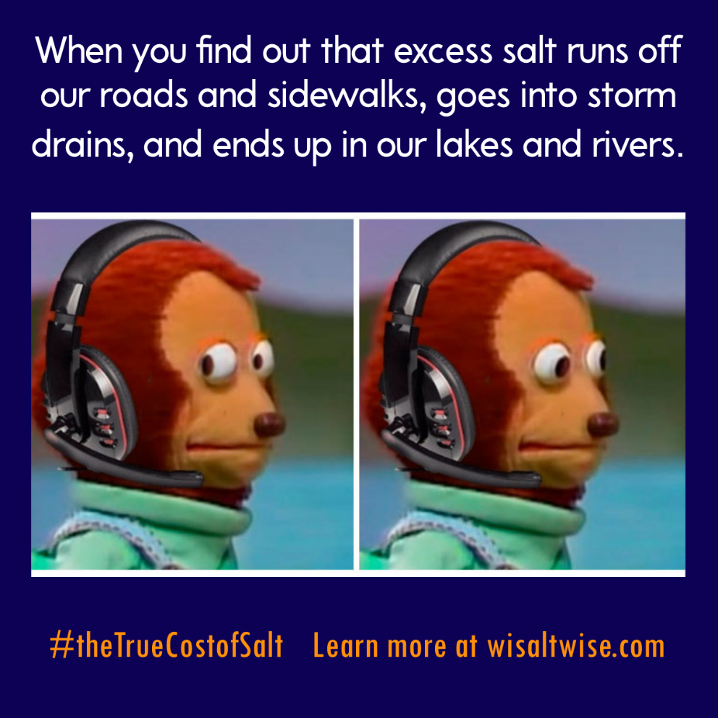

**Post 4:** Knowledge is power! Be a Salt Wise champion and help stop the salting of Wisconsin’s lakes, rivers, and drinking water. Learn how you can be a part of the salt reduction revolution during WI Salt Awareness Week, January 11-15. Register online: www.wisaltwise.com @WISaltWise

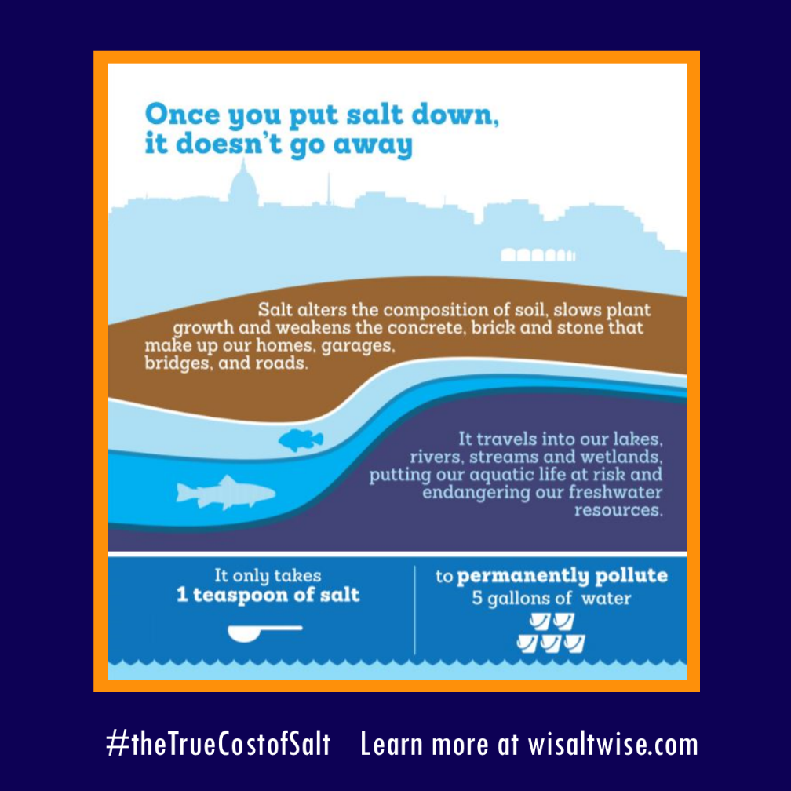

**Post 5:** All the salt that we apply to sidewalks and streets is carried by stormwater to our freshwater. Protect WI soil, water and wildlife, from the toxic effects of TOO MUCH SALT. Learn more during WI Salt Awareness Week, Jan 11-15. Register online: www.wisaltwise.com @WISaltWise

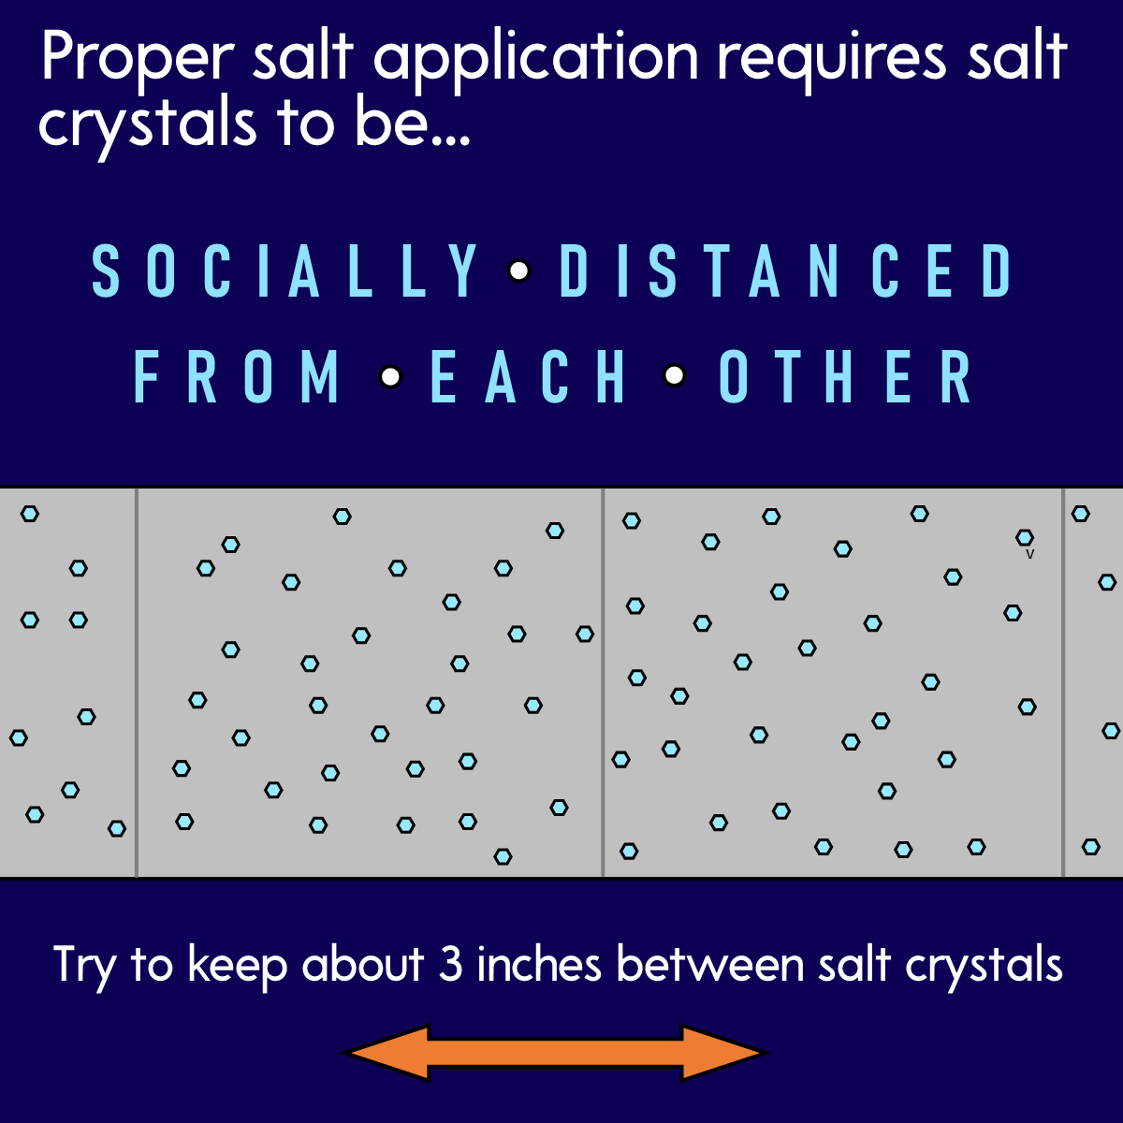

**Post 6:** Save our children and grandchildren from another public health emergency. The salt that we apply to sidewalks and roads is infiltrating our groundwater. For most Wisconsinites, groundwater is drinking water. Protect Wisconsin freshwater for future generations and right-size your salt use. @WISaltWise

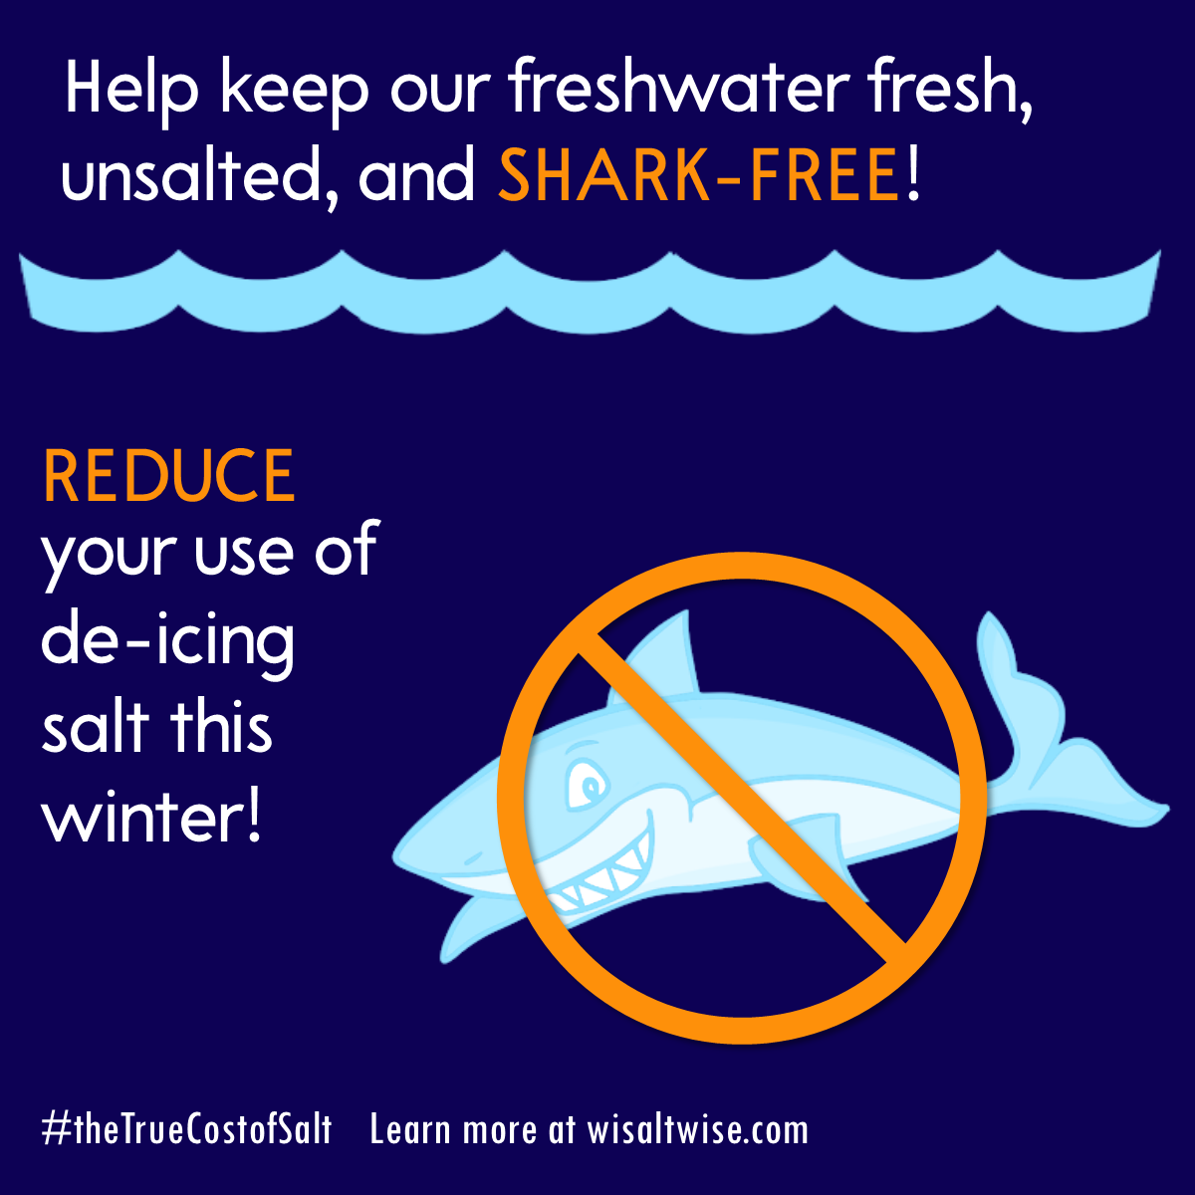

**Post 7:** We’re still looking good on the shark front, but as chloride concentrations increase in our lakes, invasive species like zebra mussels and Eurasian watermilfoil that are more tolerant of salt water threaten to further outcompete native species. @WISaltWise



**Post 8:** Every teaspoon of salt you save, helps keep 5 gallons of Wisconsin freshwater fresh. While we can’t remove salt from water, we can prevent it from entering in the first place. Snap a pic of someone using a shovel or ice scraper and share a #saltwiseshoutout this winter! @WISaltWise