**Salt Awareness Social Media**

Graphics, text and sample post schedule below. Include salt hashtags as you see fit: #keepitfreshwi; #saltwiseshoutout; #sweepthesalt; #thetruecostofsalt; #keepfreshwaterfresh

Tag us: @wisaltwise and other relevant organizations

If using posts 1-7, please use on/before Salt Awareness Week (Jan 24-28) or alter the text.

**Post on Jan 10 th**

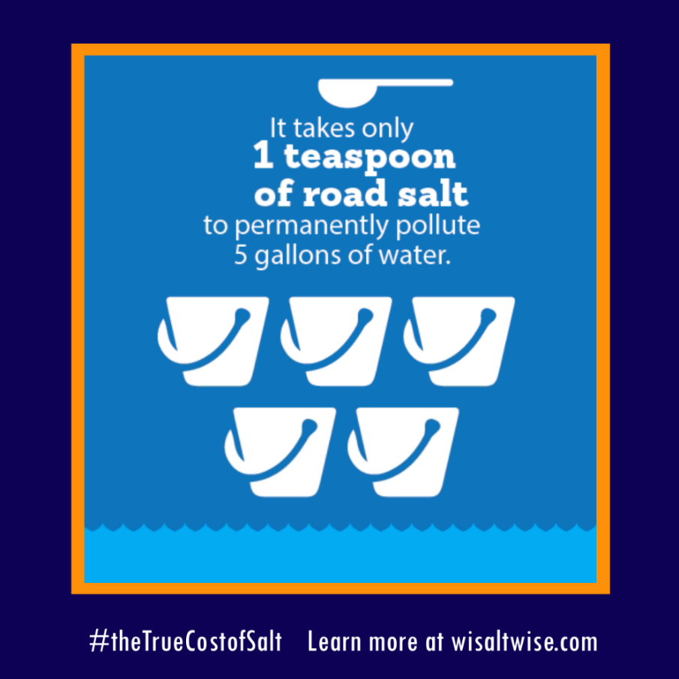

**Post 1:** One teaspoon of salt is all that it takes to make 5 gallons of water toxic for freshwater organisms. Over 40 lakes and streams in Wisconsin have been designated as impaired by high salt concentrations. Learn more during WI Salt Awareness Week, Jan 24-28. Register online: [www.wisaltwise.com](http://www.wisaltwise.com) [@WISaltWise](https://www.facebook.com/WISaltWise)

**Post on Jan 12th**



**Post 2:** Knowledge is power! Empower winter maintenance professionals at schools, businesses, etc. in your community to get Salt Wise-certified and help stop the salting of Wisconsin’s lakes, rivers, and drinking water. Register online: [www.wisaltwise.com](http://www.wisaltwise.com) [@WISaltWise](https://www.facebook.com/WISaltWise)

**Post on Jan 14th**

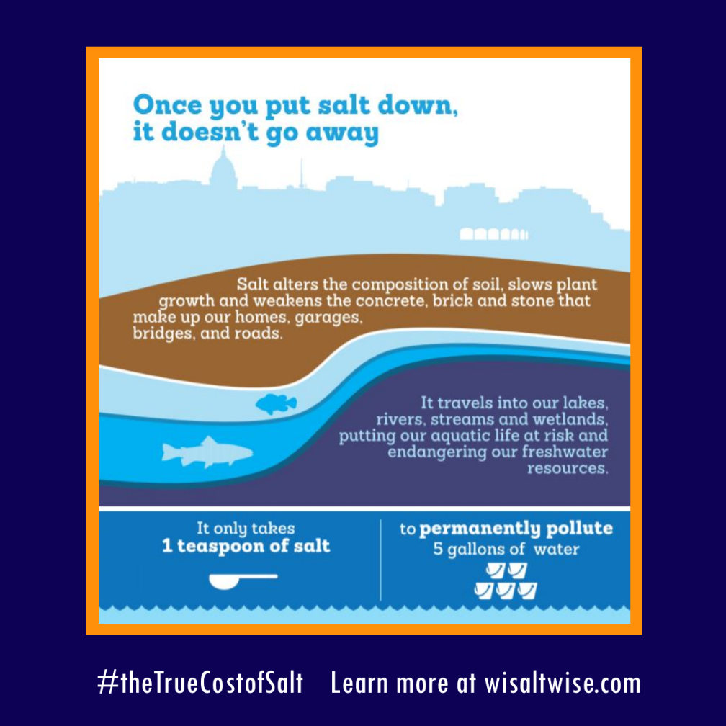

**Post 3:** Nationwide winter salt causes 5 billion dollars in damage to infrastructure each year. We can do better. Learn more during WI Salt Awareness Week, Jan 24-28. Register online: [www.wisaltwise.com](http://www.wisaltwise.com) [@WISaltWise](https://www.facebook.com/WISaltWise)

**Post on Jan 17th**

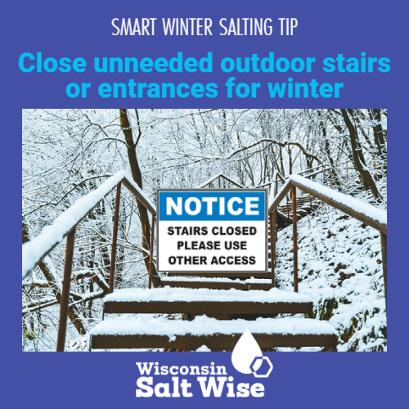

**Post 4:** A great Salt Wise hack is to close unneeded stairs and walkways during the snowy months. Learn more during WI Salt Awareness Week, January 24-28. Register online: [www.wisaltwise.com](http://www.wisaltwise.com) [@WISaltWise](https://www.facebook.com/WISaltWise)

**Post on Jan 19th**



**Post 5:** Shovel up snow as soon as possible and reduce the need for salt. Learn more about the impacts of salt on our pets during WI Salt Awareness Week, January 24-28. Register online: [www.wisaltwise.com](http://www.wisaltwise.com) [@WISaltWise](https://www.facebook.com/WISaltWise)

**Post on Jan 21st**

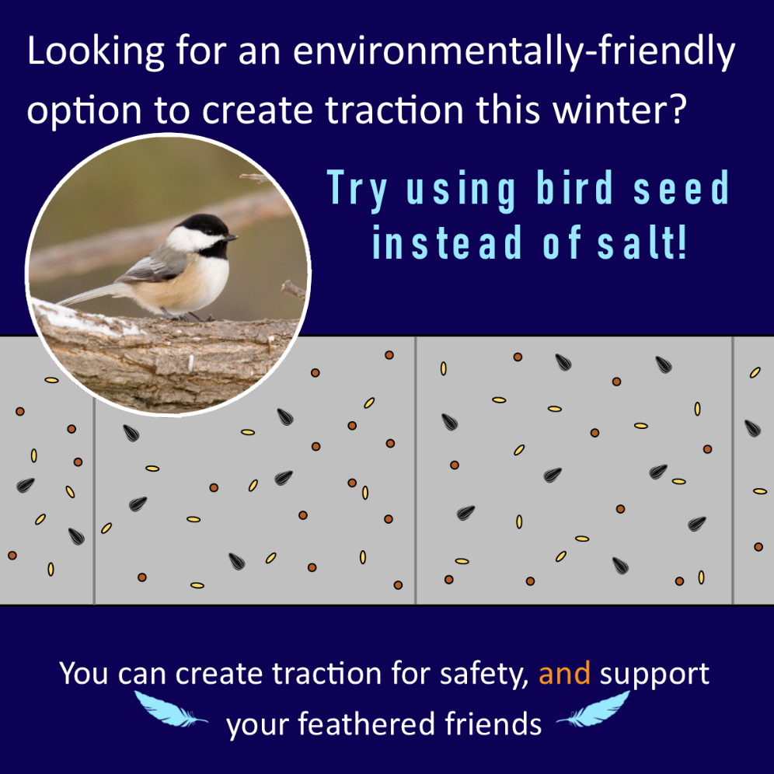

**Post 6:** Over-salting is for the birds. Wait, no, birdseed is for the birds. Support feathery friends AND protect freshwater by using birdseed for traction. Join the salt reduction revolution during WI Salt Awareness Week, Jan. 24-28. Register online: [www.wisaltwise.com](http://www.wisaltwise.com) [@WISaltWise](https://www.facebook.com/WISaltWise)

**Post on Jan 23rd**

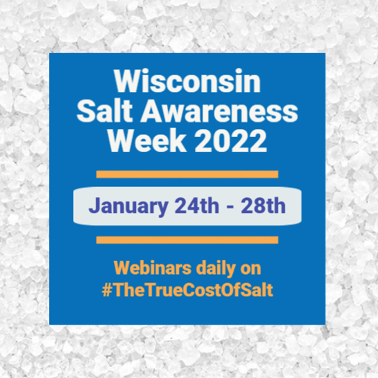

**Post 7:** As salt concentrations rise in our lakes, streams, and drinking water, Wisconsin workers are rethinking winter maintenance. Learn about the impacts of oversalting and how you can be Salt Wise during WI Salt Awareness Week, Jan. 24-28. Register online: [www.wisaltwise.com](http://www.wisaltwise.com) [@WISaltWise](https://www.facebook.com/WISaltWise)

**Post on Jan 24th before 8AM**



**Post 8:** Tune in today to learn about the environmental impacts of salt. Register online: [www.wisaltwise.com](http://www.wisaltwise.com) [@WISaltWise](https://www.facebook.com/WISaltWise)

**Post on Jan 25th before 8AM**

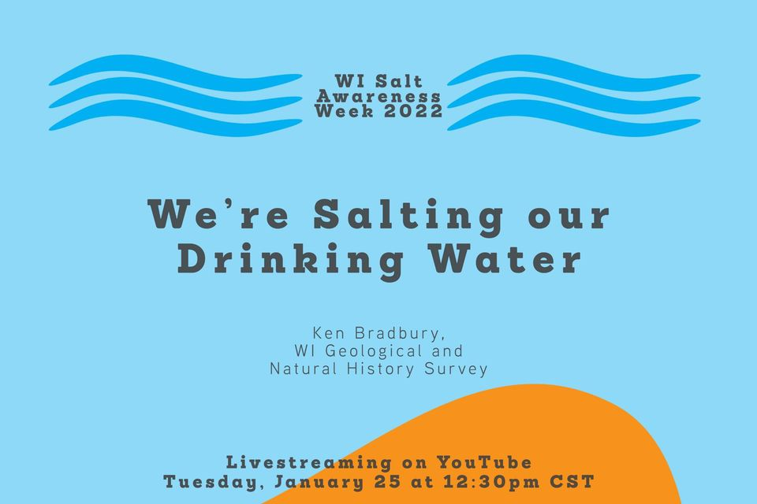

**Post 9:** Tune in today to learn about how “We’re Salting our Drinking Water”. Register online: [www.wisaltwise.com](http://www.wisaltwise.com) [@WISaltWise](https://www.facebook.com/WISaltWise)

**Post on Jan 26th before 8AM**

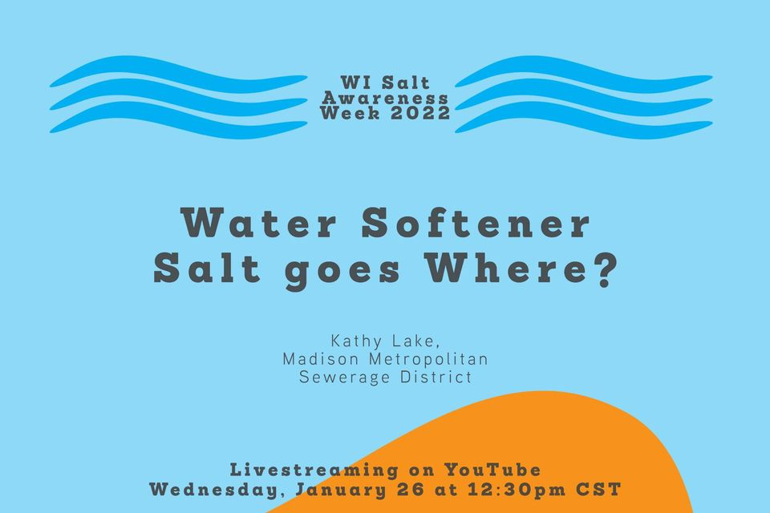

**Post 10**: Tune in today to learn where our water softener salt ends up. Register online: [www.wisaltwise.com](http://www.wisaltwise.com) [@WISaltWise](https://www.facebook.com/WISaltWise)

**Post on Jan 27th before 8AM**



**Post 11**: Tune in today to learn how to teach about salt. Register online: [www.wisaltwise.com](http://www.wisaltwise.com) [@WISaltWise](https://www.facebook.com/WISaltWise)

**Post on Jan 28th before 8AM**

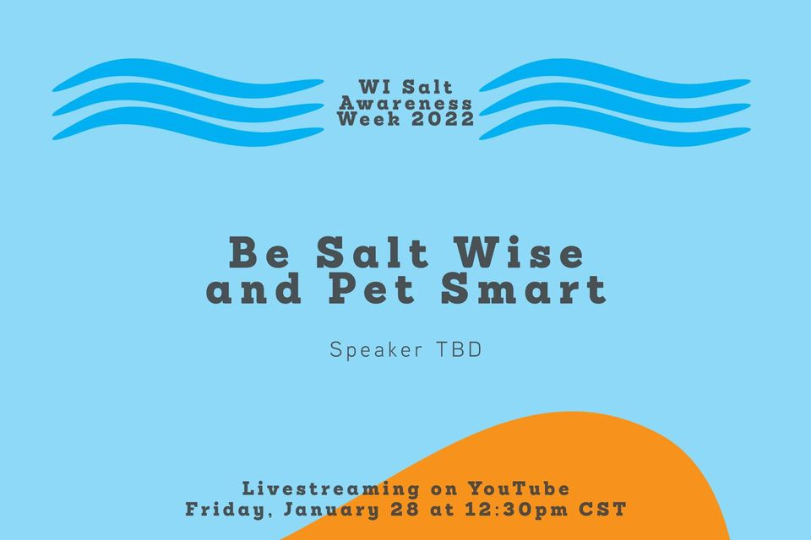

**Post 12**: Tune in today to learn how salt impacts pets and actions you can take to protect them. Register online: [www.wisaltwise.com](http://www.wisaltwise.com) [@WISaltWise](https://www.facebook.com/WISaltWise)

**Post on Feb. 1st**

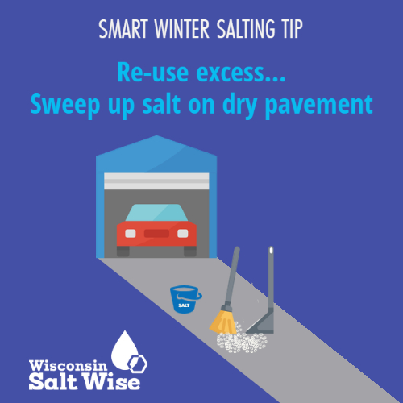

**Post 13:** Salt might appear to disappear, but it doesn’t “go away.” Be a freshwater champion, and #sweepthesalt. Learn more about the impacts of over-salting at [www.wisaltwise.com](http://www.wisaltwise.com) [@WISaltWise](https://www.facebook.com/WISaltWise)

**Post on Feb. 3rd**

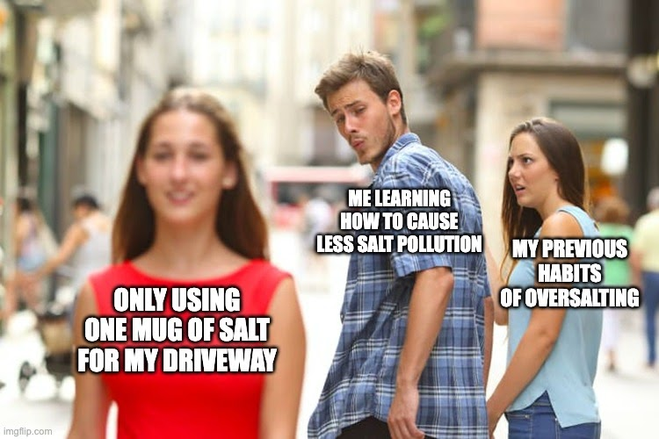

**Post 14:** Spread the word: a coffee mug of salt is enough to treat an entire 20-foot driveway or 10 sidewalk squares! Don’t stay wed to your oversalting habits this season. #noplanetb

**Post on Feb. 8th**

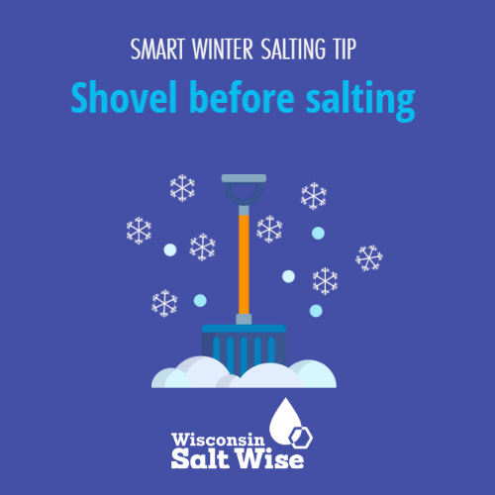

**Post 15:** The more snow that you can remove with a shovel or snowblower the better. If you can get out early, the sun can sometimes take care of the rest, no salt needed! #keepfreshwaterfresh #shovelfirst

**Post on Feb. 10th**

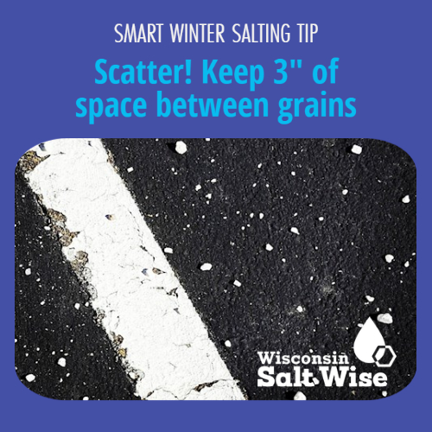

**Post 16:** It’s easy to over apply salt. Stick to the 3” rule and keep extra salt out of our lakes and streams. Learn more at [www.wisaltwise.com](http://www.wisaltwise.com) [@WISaltWise](https://www.facebook.com/WISaltWise)

**Post on Feb. 15th**

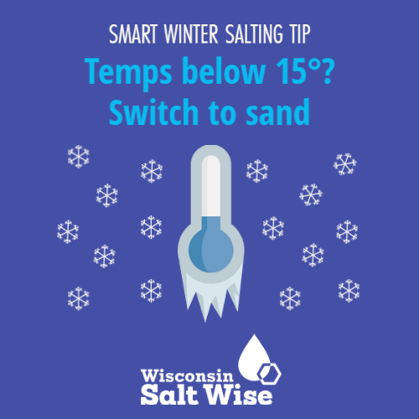

**Post 17:** Salt isn’t effective below 15 degrees. When temperatures dip, switch to sand for traction to protect your pavement and our freshwater. Learn more at [www.wisaltwise.com](http://www.wisaltwise.com) [@WISaltWise](https://www.facebook.com/WISaltWise)

**Post on Feb. 17th**

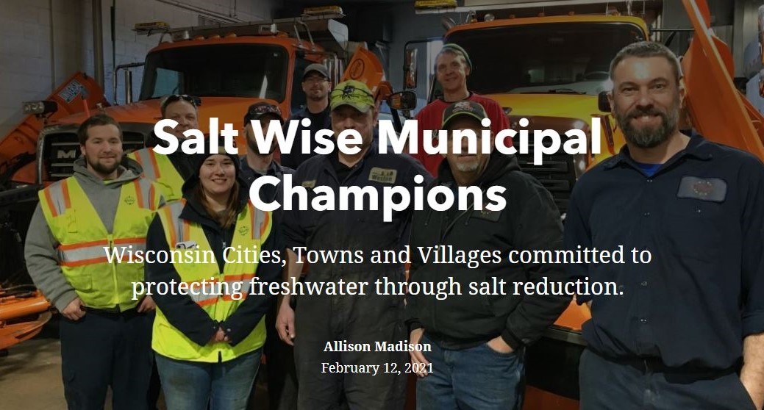

**Post 18:** From Superior to Sheboygan, municipalities across Wisconsin are taking huge steps to right-size their salt use. Several communities have cut total salt use by 50%; learn how at: <https://www.wisaltwise.com/Take-Action/Winter-Maintenance-Professionals/Municipal-Champions>

**Post on Feb. 22nd**

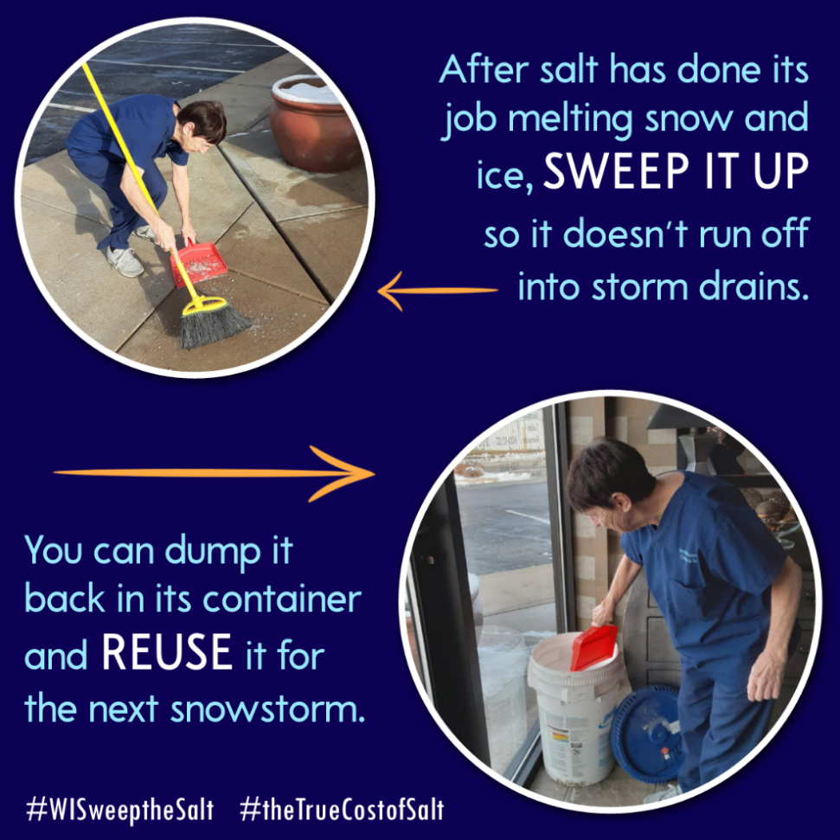

**Post 19:** Salt might appear to disappear, but it doesn’t “go away.” Be a freshwater champion, and #sweepthesalt.